Ideation Phase
Define the Problem Statements

Date | 15 October 2026
Team ID | 23891A05C2
Project Name | Medical Diagnosis Center
Maximum Marks | 2 Marks

Problem Statement: Patient Appointment Booking and Report Tracking
I am a patient trying to book a diagnostic test and receive my report on time, but appointments and report updates are difficult to track because the process is manual and disconnected, which makes me feel worried and frustrated.
Solution: A ServiceNow application that enables easy online test booking, appointment confirmation, notifications, and secure access to medical reports.

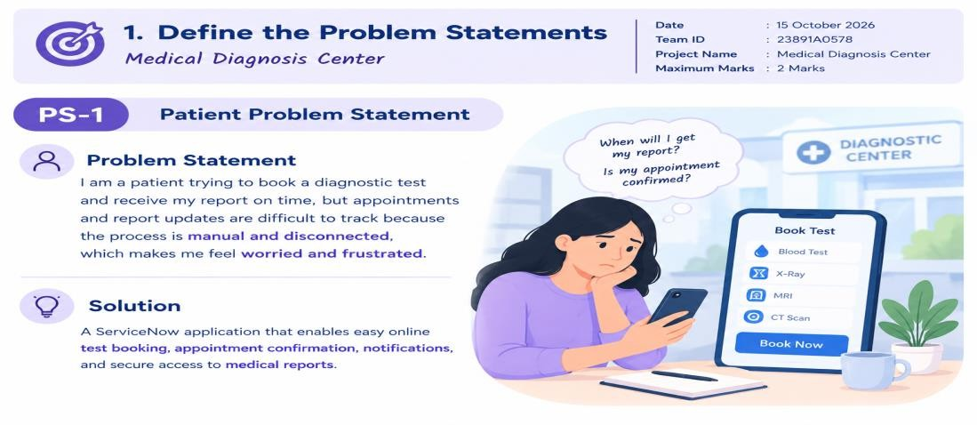

PS-1: Patient Problem
Problem Statement: I am a patient trying to book a diagnostic test and receive my report on time, but appointments and report updates are difficult to track because the process is manual and disconnected, which makes me feel worried and frustrated.

PS-2: Receptionist Problem
Problem Statement: I am a receptionist at a diagnostic center trying to manage patient details, test bookings, and appointments efficiently, but overlapping bookings and repeated follow-ups occur because records and updates are handled across separate processes, which makes me feel stressed.

Example:

